Project Design Phase-II
Data Flow Diagram & User Stories

Date | 08 October 2026
Team ID | 9100SmartGirls
Project Name | Streamlining IT Procurement: Automating Standard Laptop Orders with Flow Designer
Maximum Marks | 4 Marks

Data Flow Diagrams:
Proposed Level-1 DFD for the standard laptop procurement automation: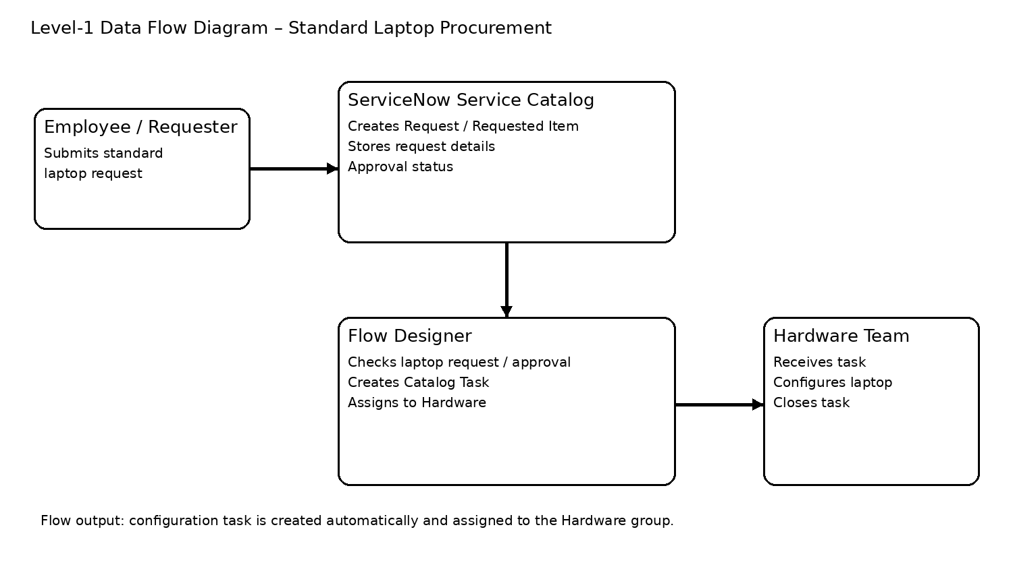
A Data Flow Diagram (DFD) is a traditional visual representation of the information flows within a system. A neat and clear DFD can depict the right amount of the system requirement graphically. It shows how data enters and leaves the system, what changes the information, and where data is stored.
Example: DFD Level 0 (Industry Standard)



User Stories
Use the below template to list all the user stories for the product.
User Type | Functional Requirement (Epic) | User Story Number | User Story / Task | Acceptance criteria | Priority | Release
IT Procurement Team Member | Submit Standard Laptop Request | USN-1 | As an IT procurement team member, I can submit a standard laptop request through the Service Catalog so the request enters the standard procurement process. | Request is created successfully in ServiceNow. | High | Sprint-1
ServiceNow Flow | Identify Laptop Request | USN-2 | As the automation, I identify a qualifying standard laptop request so only the intended request follows the configuration workflow. | The qualifying Requested Item is identified by the flow condition. | High | Sprint-1
ServiceNow Flow | Check Approval | USN-3 | As the automation, I check the required approval condition before starting configuration work. | The flow proceeds only when the required condition is satisfied. | High | Sprint-1
ServiceNow Flow | Create Catalog Task | USN-4 | As the automation, I automatically create a Catalog Task for laptop configuration so the procurement team does not create it manually. | A Catalog Task is created and linked to the Requested Item; short description is “Laptop needs to be configured”. | High | Sprint-1
ServiceNow Flow | Assign Hardware Team | USN-5 | As the automation, I assign the configuration task to the Hardware assignment group so the correct team receives the work. | The task assignment group is Hardware. | High | Sprint-1
Hardware Team | Configure Laptop | USN-6 | As a Hardware team member, I can receive the assigned configuration task and configure the standard laptop. | The task is visible to Hardware and can be worked on. | High | Sprint-2
Hardware Team | Close Configuration Task | USN-7 | As a Hardware team member, I can close the configuration task after completing laptop configuration. | The Catalog Task is closed and the request can proceed. | High | Sprint-2
IT Procurement Team Member | Verify Automation | USN-8 | As an IT procurement team member, I can verify that the flow runs and the task is automatically created and assigned. | A test request produces the expected Catalog Task with Hardware assignment. | Medium | Sprint-2

